**Report**

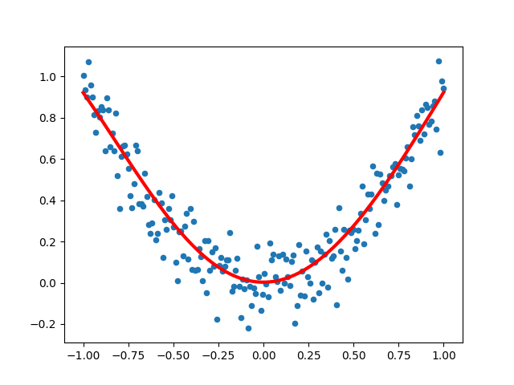

data_and_function

I follow the instructions and hints to complete the functions, then test my code by running toy_example_regressor.py, prime_classifier.py and evaluate_assignment.py, then fix the problem and test my code again.

Toy:

[Epoch 0]: loss: 11.849840680207045

[Epoch 0]: loss: 6.415041388570392

[Epoch 0]: loss: 3.2045493964415552

[Epoch 50]: loss: 0.08639302372940084

[Epoch 50]: loss: 0.06355492087682417

[Epoch 50]: loss: 0.10430830250754455

[Epoch 100]: loss: 0.0667864986274947

[Epoch 100]: loss: 0.043070342402683266

[Epoch 100]: loss: 0.07336165251287292

[Epoch 150]: loss: 0.058024677774894944

[Epoch 150]: loss: 0.03501619889368944

[Epoch 150]: loss: 0.05945252714791631

[Epoch 200]: loss: 0.05015711709868256

[Epoch 200]: loss: 0.0291554545756946

[Epoch 200]: loss: 0.05007075093495725

[Epoch 250]: loss: 0.042617746830282154

[Epoch 250]: loss: 0.02415525989724089

[Epoch 250]: loss: 0.04253706011446123

[Epoch 300]: loss: 0.03585074147278868

[Epoch 300]: loss: 0.019992677375035926

[Epoch 300]: loss: 0.03626870717954512

[Epoch 350]: loss: 0.030126536711588357

[Epoch 350]: loss: 0.016711992078656167

[Epoch 350]: loss: 0.03113406771250146

[Epoch 400]: loss: 0.02549545618901762

[Epoch 400]: loss: 0.014268265884217932

[Epoch 400]: loss: 0.027049655917991123

[Epoch 450]: loss: 0.021873288891892752

[Epoch 450]: loss: 0.012547788294916581

[Epoch 450]: loss: 0.02389634611342621

[Epoch 500]: loss: 0.01911211153806263

[Epoch 500]: loss: 0.011406532030974512

[Epoch 500]: loss: 0.021524380151930256

[Epoch 550]: loss: 0.017046724026484963

[Epoch 550]: loss: 0.01070009800911031

[Epoch 550]: loss: 0.01977676853518588

[Epoch 600]: loss: 0.015521602593686588

[Epoch 600]: loss: 0.010301524807819254

[Epoch 600]: loss: 0.018508520399747173

[Epoch 650]: loss: 0.01440376231539285

[Epoch 650]: loss: 0.010108810777512606

[Epoch 650]: loss: 0.01759690772700774

[Epoch 700]: loss: 0.013586451521400483

[Epoch 700]: loss: 0.01004544743300226

[Epoch 700]: loss: 0.0169443067865402

[Epoch 750]: loss: 0.012987649335143785

[Epoch 750]: loss: 0.010057251985814728

[Epoch 750]: loss: 0.01647648951766266

[Epoch 800]: loss: 0.012546277972433077

[Epoch 800]: loss: 0.010107806902074088

[Epoch 800]: loss: 0.016138861647197238

[Epoch 850]: loss: 0.012217840730803536

[Epoch 850]: loss: 0.01017386559008349

[Epoch 850]: loss: 0.01589226800834974

[Epoch 900]: loss: 0.011970390642428712

[Epoch 900]: loss: 0.01024147445393219

[Epoch 900]: loss: 0.01570909960403362

[Epoch 950]: loss: 0.011781199604152755

[Epoch 950]: loss: 0.010302929658207116

[Epoch 950]: loss: 0.015570140226694493

Validation Loss 0.01128530784036602

Prime:

[Epoch 0]: validation loss: 0.20135027, validation accuracy: 69.36%

[Epoch 1]: validation loss: 0.11589750, validation accuracy: 85.96%

[Epoch 2]: validation loss: 0.09951013, validation accuracy: 87.46%

[Epoch 3]: validation loss: 0.09272672, validation accuracy: 88.22%

[Epoch 4]: validation loss: 0.08894021, validation accuracy: 88.76%

[Epoch 5]: validation loss: 0.08646042, validation accuracy: 89.03%

[Epoch 6]: validation loss: 0.08460486, validation accuracy: 89.33%

[Epoch 7]: validation loss: 0.08283331, validation accuracy: 89.45%

[Epoch 8]: validation loss: 0.08034576, validation accuracy: 89.83%

[Epoch 9]: validation loss: 0.07701915, validation accuracy: 90.26%

[Epoch 10]: validation loss: 0.07336158, validation accuracy: 90.82%

[Epoch 11]: validation loss: 0.06953909, validation accuracy: 91.49%

[Epoch 12]: validation loss: 0.06556480, validation accuracy: 92.03%

[Epoch 13]: validation loss: 0.06145956, validation accuracy: 92.71%

[Epoch 14]: validation loss: 0.05736161, validation accuracy: 93.29%

[Epoch 15]: validation loss: 0.05348172, validation accuracy: 93.83%

[Epoch 16]: validation loss: 0.05002990, validation accuracy: 94.34%

[Epoch 17]: validation loss: 0.04706440, validation accuracy: 94.62%

[Epoch 18]: validation loss: 0.04454474, validation accuracy: 94.83%

[Epoch 19]: validation loss: 0.04240104, validation accuracy: 95.09%

[Epoch 20]: validation loss: 0.04056526, validation accuracy: 95.27%

[Epoch 21]: validation loss: 0.03898068, validation accuracy: 95.49%

[Epoch 22]: validation loss: 0.03760219, validation accuracy: 95.70%

[Epoch 23]: validation loss: 0.03639403, validation accuracy: 95.88%

[Epoch 24]: validation loss: 0.03532722, validation accuracy: 95.97%

[Epoch 25]: validation loss: 0.03437793, validation accuracy: 96.06%

[Epoch 26]: validation loss: 0.03352654, validation accuracy: 96.10%

[Epoch 27]: validation loss: 0.03275712, validation accuracy: 96.23%

[Epoch 28]: validation loss: 0.03205689, validation accuracy: 96.30%

[Epoch 29]: validation loss: 0.03141567, validation accuracy: 96.38%

[Epoch 30]: validation loss: 0.03082534, validation accuracy: 96.43%

[Epoch 31]: validation loss: 0.03027935, validation accuracy: 96.48%

[Epoch 32]: validation loss: 0.02977239, validation accuracy: 96.54%

[Epoch 33]: validation loss: 0.02930009, validation accuracy: 96.61%

[Epoch 34]: validation loss: 0.02885878, validation accuracy: 96.62%

[Epoch 35]: validation loss: 0.02844536, validation accuracy: 96.64%

[Epoch 36]: validation loss: 0.02805717, validation accuracy: 96.65%

[Epoch 37]: validation loss: 0.02769191, validation accuracy: 96.73%

[Epoch 38]: validation loss: 0.02734757, validation accuracy: 96.76%

[Epoch 39]: validation loss: 0.02702238, validation accuracy: 96.81%

[Epoch 40]: validation loss: 0.02671475, validation accuracy: 96.81%

[Epoch 41]: validation loss: 0.02642328, validation accuracy: 96.86%

[Epoch 42]: validation loss: 0.02614671, validation accuracy: 96.89%

[Epoch 43]: validation loss: 0.02588390, validation accuracy: 96.97%

[Epoch 44]: validation loss: 0.02563382, validation accuracy: 96.99%

[Epoch 45]: validation loss: 0.02539553, validation accuracy: 97.04%

[Epoch 46]: validation loss: 0.02516819, validation accuracy: 97.05%

[Epoch 47]: validation loss: 0.02495103, validation accuracy: 97.08%

[Epoch 48]: validation loss: 0.02474334, validation accuracy: 97.11%

[Epoch 49]: validation loss: 0.02454448, validation accuracy: 97.12%